- October Meeting Attendance
The October meeting was held on Sunday, 11 Oct 2015 at 6:30 PM, at the Swamp Rabbit Inn, 1 Logan Street, Greenville SC29601. 7 of our 15 Board Members were present. We did not have a quorum, so no votes took place.

In Attendance:
- Vice-President - George Furr
- Secretary - Jamie France
- Treasurer - Karen Bailey
- Safety Foundation - Nancy Wolfe
- Advocacy - Frank Mansbach
- Rides - Dan McNamara
- Membership – Chris Nordmeyer (co-chair w/Londa Jones)
Absent:
- President - Don Hudson
- Public Relations - Steve Baker
- Racing Chair - Rip Major
- Touring Chair - Kyle Danner
- Webmaster - Dominic Epsom
- GS Elan - Robin Bylenga
- Mountain Biking – Scott Brunner
- Member-at-Large - Sam Smith

Guests/Club Members in attendance: Carlo & Sarah Franco (Velo Valet)

- Agenda Items Discussed
- Don is leading an initiative to restructure the club’s Board. In his absence, Don submitted a proposal via George that we do away with two positions: GS Elan and Mountain Biking. Jamie added a proposal to change Webmaster to a non-voting position and to encourage co-chairs as an option (1 vote per chair, not per person). No voting could occur as we did not have a quorum.
- Dominic was not able to be present. The Board is awaiting his plan for upgrading our website, potentially switching from Club Express.
- Dan floated some ideas for the Tuesday night SCTAC ride organization for 2016.
- The Board recognized the support given by Josh Boggs and The Trek Store during 2015 Tuesday nights at SCTAC. Dan will arrange some official acknowledgement.
- Chris suggested that he and Londa can assist Sam with the Holiday Party.
- Chris asked about Spinners logo stickers for members. Jamie and George showed him the “classier” white on clear style of stickers (with no year on them) that we would prefer. George will give Chris the printer contact.
- Frank is looking into how to get Greenville County’s most-used cycling routes into the official county master plan so that they may be recognized by SCDOT. The hopes are that officially recognized routes could be considered for improvements such as widening or bike-friendly rumble strips.
- The Spinners Safety Foundation is awaiting approval from Greenville County Rec on the verbiage for the “Burma Shave style” signs on the SRT.
- The First 50 ride will be Saturday, 2 January, from Furman to benefit the Safety Foundation. Nancy and Ken Drescher are working on the ride, but will need some morning-of registration volunteers.
- Treasury Balance: $16,564.49 in checking account on 10/11/2016; $11,905.63 in investments on 9/13/16 (no update available).
- Karen got an email from Ken Drescher in which, at the Board’s request, he reanalyzed our investment instruments. The Board needs to evaluate his suggestions further.
- Karen presented the P&L from the new accountant:
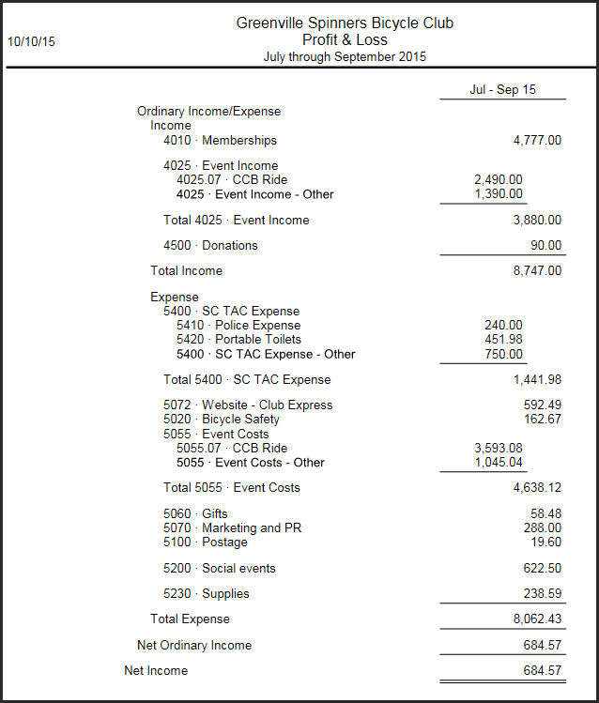
- Now that SCTAC Tuesday night rides are over for the year, Karen will call the port-a-john company and have them picked up.
- George updated us on 2016 Board positions. The slate is not firm yet. The discussion will continue via email correspondence until the November Board meeting. Any club members interested in serving in any position should contact Don Hudson or George Furr without delay.

- For Next Meeting(s)
Board Members – please try your utmost to attend. We need a quorum to vote on some important proposals.
- Update from Sam on Holiday Party.
- Update from Dominic on website.
- Update from Steve on outreach/letter to local bike shops.
- Update from George on filling 2016 open Board positions.
- Vote on annual contributions to the Palmetto Cycling Coalition and to Bike Walk Greenville.
- Don -- open item that needs scheduling: summarize & brief the Board on our insurance policies.
- A representative from Roger C. Peace will attend a future meeting to share info about their adaptive cycling program (Jamie is arranging).

- Reminder: 2015 Meetings & Location
All meetings are open to all club members. Minutes will be emailed to the club, and posted on the website. Jan-Nov meetings will start at 6:30 PM, at the Swamp Rabbit Inn, 1 Logan Street, Greenville SC29601.
- 8 Nov
- 13 Dec – Holiday Party (time & location TBD)

