- October Meeting Attendance
The November meeting was held on Sunday, 8 Nov 2015 at 6:30 PM, at the Swamp Rabbit Inn, 1 Logan Street, Greenville SC29601. 8 of our 15 Board Members were present.

In Attendance:
- President - Don Hudson
- Vice-President - George Furr
- Secretary - Jamie France
- Treasurer - Karen Bailey
- Safety Foundation - Nancy Wolfe
- Advocacy - Frank Mansbach
- Racing Chair - Rip Major
- Membership – Chris Nordmeyer & Londa Jones
Absent:
- Public Relations - Steve Baker
- Rides - Dan McNamara
- Touring Chair - Kyle Danner
- Webmaster - Dominic Epsom
- GS Elan - Robin Bylenga
- Mountain Biking – Scott Brunner
- Member-at-Large - Sam Smith

Guests/Club Members in attendance: Mike Pennington, Carlo & Sarah Franco (Velo Valet).

- Agenda Items Discussed
- Holiday Party invite went out as having a cash bar; board voted in favor of changing it BYOB.
- No update on new website plans. Don will call Wendy to ask her to forward her proposal to him for the board to review.
- Outreach letter was sent to local bike shops and cycling-related businesses with a favorable reaction. Don has received a few responses from those wanting to partner with us. He will continue dialogue with responders.
- We eliminated Webmaster and GS Elan from the voting board positions in an email vote two weeks ago. We voted to eliminate Mountain Biking from the voting board positions tonight. George reported that with these eliminations, the 2016 Board slate is now filled. The membership will vote on the slate at the Holiday Party.
- Karen stated that we have a letter confirming our 501c7 tax status. She will send a pdf of it to Jamie for uploading to the document library.
- Treasury Balance: $16,672.47 in checking account on 11/08/2016; $11,905.63 in investments on 9/13/16 (no update available).
- The new accountant is in place. Fee is $75/month. Karen presented the current P&L:
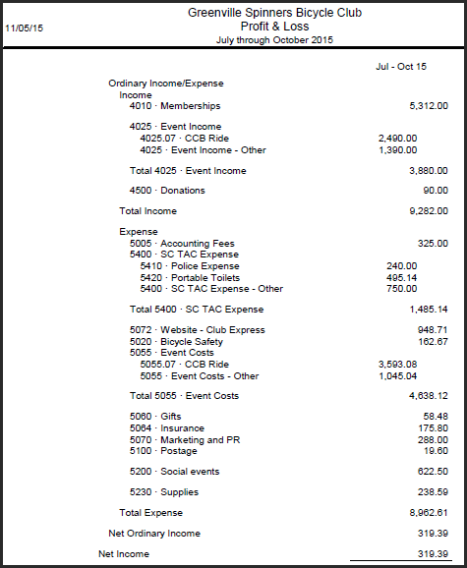
- We voted in favor of a 2015 contribution to Bike Walk Greenville in the amount of $2,000. Last year, we contributed $500. Increase was approved due to the acknowledged progress they have made in the community.
- We voted in favor of a 2015 contribution to the Palmetto Cycling Coalition in the amount of $1,000. Last year, we contributed $1,000.
- Race team is still recruiting for next year. Kit fit drop-in is 11/12. Interested members should contact Rip ASAP.
- Chris and Londa will move forward with Spinners logo stickers for members once they get the graphics file (which is stored in our documents library).
- Leaf Tour resulted in over 30 new members.
- Spinners Safety Foundation has approval from Greenville County Rec on the verbiage for the “Burma Shave style” signs on the SRT. Next step is to install them.
- Safety Foundation is on track to give away 250 kids helmets by January 2016.
- Safety Foundation call-a-thon is 11/30. Volunteers are needed.
- Annual Boys & Girls Club bike give-away may need assistance with funding; Nancy will let board know if & when they do.
- The First 50 ride will be Saturday, 2 January, from Furman to benefit the Safety Foundation.
- A new parking area is open with access to the Swamp Rabbit Trail. Area is on Hudson St, has 40 spaces, and a water fountain.
- Our Yahoo group (voluntary email distribution) is up over 600 members. Chris will cleanse it by comparing the Yahoo group to current members and deleting non-members.
- Altamont over Paris Mountain has been paved, and there is also a new “pull out.” Don proposed a ride & social event for volunteers to clean-up the top of Paris Mountain (where antennas are) as a thank you to the residents. Board approved Don to spend on some refreshments for the volunteers, at his discretion (~$100).
- Natchez Trace Tour was a success: 10 riders and 1 SAG. Next year, Don is planning a Blue Ridge Parkway end-to-end ride in September. This will be a Spinners Club event.

- For Next Meeting(s)
- Don -- open item that needs scheduling for a 2016 meeting: summarize & brief the Board on our insurance policies.

- Reminder: Upcoming Meetings
All meetings are open to all club members. Minutes will be emailed to the club, and posted on the website.
- 13 Dec 2015 – 6:30 PM, Holiday Party (Montebello Club House, 810 State Park Road, Greenville SC 29609)
- 10 Jan 2016 - 6:30 PM at the Swamp Rabbit Inn
- Remaining 2016 meeting dates will be firmed at the January meeting; schedule should follow our pattern of 2nd Sunday evening of each month.

